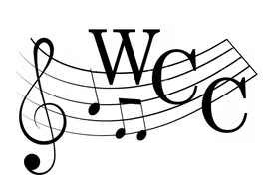WESTBOROUGH COMMUNITY CHORUS

Dear Advertiser, Spring 2025

Westborough Community Chorus, Inc. is a local non-profit that provides community musical enjoyment and supports local students through music lesson scholarships.

**We are reaching out to request your generous support.** By placing an ad in our Spring 2025 production program, you’ll help fund scholarships for Westborough Middle and High School students, enabling them to take voice and instrumental lessons. Your contribution will directly empower young musicians to develop their talents and foster a love of music that will last a lifetime.

The show, Be Our Guest, is May 2nd, 3rd, and 4th at Gibbons Middle School in Westborough. Join us for a magical evening as Westborough Community Chorus brings to life the timeless tunes of Disney. Scholarship recipients perform during the show.

We appreciate your anticipated participation.

Please submit the following form with your ad and either cash, check, or online payment by

# March 17th.

1. We recommend supplying gray-scale vector art or an image digitally. Please submit the form with artwork electronically to [ads@westboroughcommunitychorus.com](mailto:ads@westboroughcommunitychorus.com).
2. We also accept camera ready, black and white artwork or a business card with the form.

*If you previously placed an ad with us, we have these on file and can reuse content upon request.*

Chorus Contact Person: Click or tap here to enter text.

# Advertiser Information

Company: Click or tap here to enter text. Contact: Click or tap here to enter text.

Phone #: Click or tap here to enter text. Email: Click or tap here to enter text.

**Advertisement Size:**

Business Card or

⅓ page ($60)

# Payment Type:

Half Page ($100)

Full Page ($150)

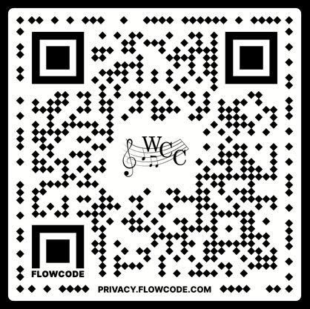Cash or Check *made payable to Westborough Community Chorus, Inc.*

Square Payment (QR Code)

Venmo @wcc_1971

Visit [westborocommunitychorus.com/sponsors](http://westborocommunitychorus.com/sponsors) to access this form and/or pay online.